Warm/Cool Shoe Painting
Name:
Period:
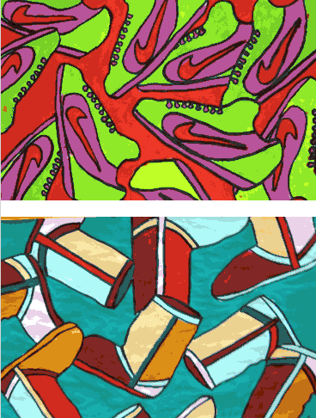
Supplies:
- A pencil
- An eraser
- Sharpie
- White Paper
- Watercolor Paint
- Paintbrushes
Vocab To Know:
Contour Lines, Warm Colors, Cool Colors, Composition, Still Life, Repetition
Directions:
- For this project, you need to try to wear the same shoes every day! We will be “drawing from life” which means we will be looking at our actual shoes.
- Take off one of your shoes and place it on the table.
- Using your practice paper, practice using CONTOUR LINES to draw your shoe life size (the actual size of the shoe). Remember, draw what you see, not what you think you see!
- Once you have accurately drawn your shoe on the practice paper, see Miss Warner to get your big piece of paper.
- WRITE YOUR NAME ON THE BACK OF YOUR PAPER!!!!!!!!!
- Begin drawing your shoe about 10 times on your large paper IN PENCIL. Take your time with your drawing and remember to only use CONTOUR LINES.
  - Think about your composition (the way you will arrange your shoes).
  - Try letting some shoes hang off the edge, lie at different angles, lie on top of each other, etc.
- Once you have drawn all your shoes, outline with a black sharpie.
- When all your lines are outlined, you may begin painting. You need to use both Warm and Cool Colors in your painting. Your shoe can be the warm color and the background can be the cool colors, or vice versa.
- Begin painting using the watercolor paint. Remember that by applying more water, the colors are lighter, and by applying less water, the colors will be brighter.
- When done, place on the drying rack.

