Op Art Illusions
Op Art: A type of art that use optical illusions.
You Will Need:
- A pencil
- An eraser
- Piece of paper
- Assorted markers
Directions:
- Put your name on the back of the paper (with pencil) and turn over.
- Draw a curved line from left to right across the middle of the page with your pencil.
  - 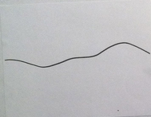
- Draw a variety of curved lines from top to bottom of the page.
  - 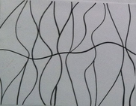

- Create Cross-Contour lines across each of the shapes (or wormies) both above and below the middle line.
  - HINT: The cross contour lines above the middle line look like n and below the middle line look like u.
  - 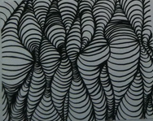
- Outline all lines when done using a black marker.
- Individually color each wormie using 2-3 colors.
  - 