Japanese Notan Art
Name:
Period:
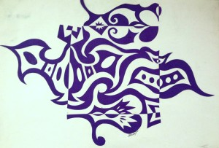
You Will Need:
- A pencil
- An eraser
- 2 pieces of a paper (1 color, 1 black)
- Scissors
- Glue
Vocab To Know:
Positive Space, Negative Space, Organic Shape, Geometric Shape, Composition, Notan, Balance,
Goal:
To create an interesting pattern of a shape of your choice to create positive and negative space.

Directions:
- Select two colored squares (1 large, 1 small) and ziplock baggie for your project from Miss Warner.
- Put your name on the ziplock baggie with a permanent marker. (This will be used to collect your paper pieces.)
- Begin to LIGHTLY draw your designs from two of the edges into the center of the square. (Refer to classroom example for idea).
Things To Remember:
  - Think of the designs as shapes.
  - You MUST cut from all 4 sides.
  - Your design needs to be balanced!
  - You must have at least 12 cuts (6 per side) on your large square.
  - You must have at least 8 cuts (4 per side) on your small square.
- Once you have your design, begin cutting shapes from the sides of the squares. Go slowly to make sure your lines are clean.
- IMMEDIATELY put all shapes into your ziplock bag. DO NOT THROW ANYTHING AWAY!!
- See Miss Warner to get the black piece of paper for gluing.
- Put your name on the back of the black paper and turn over!
- Glue down the large square in one corner of your background.
- Glue down the small square in the opposite corner of your background.
- Place all the cut shapes back into the square.
- Flip shapes and trace a light outline where each shape goes.
- Glue down in the mirror image from where it was cut. The basic idea is to cut out the piece, flip it out so that it mirrors the cut out space, and then glue it down.

