Eggcredible Shading
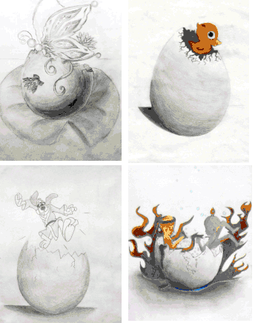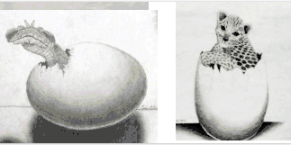
You Will Need:
A No. 2 pencil (no mechanical pencils), an eraser, paper, blending stump, magazines, scissors, glue.
Vocabulary to Know:
Value, Shade, Halftone, High Light, Cast Shadow, Shadow’s Edge, Reflected Light

Directions:
- Review and the practice the basics of shading. Complete the worksheet Miss Warner gave out in class.
- Once you have practiced, get a piece of paper from Miss Warner.
- Write your name on the back of the paper and turn it over!!!!!!!!!
- Begin to LIGHTLY sketch out an outline of an egg (oval shape) on your paper. You want to draw the egg very large so that it fills the space.
- Once you have a general egg shape, draw a crack down the middle of the egg to make it appear as if it is hatching.
- Once you have the egg shape, begin shading the egg on one side. Remember to go lightly on the edges to attempt to make the egg have a shadow under it.
- Consider the “light source” or where the light is coming from when you are creating these things.
- Brainstorm what you want to be hatching from your egg. Brainstorm what you want to be hatching from your egg. Search through the magazines and find a creative option for your egg creature.
- Cut out your creature and glue the creature coming out of your egg. Feel free to shade around the edges to make the creature fit in the picture, and don’t forget to make sure it fits with the crack lines on your egg!
  - If the animal is sitting inside an egg, how should the inside look?
- Finally, once the glue has dried, draw and shade in an interesting background that goes along with your creature. Your egg should look like it’s sitting on a table in an interesting environment.

