Supplies: Ruler, Reference Photo, Paper, Pencil

What is the Grid Method?
The grid method involves drawing a grid over your reference photo, and then drawing a grid of equal ratio on your work surface (large paper). Then you draw the image on your paper, focusing on one square at a time, until the entire image has been transferred. The important thing to remember when drawing the grids is that they must have a 1:1 ratio. A 1:1 ratio means that you will have the exact same number of lines on your canvas as you will on your reference photo, and that in both cases, the lines must be equally spaced apart.

STEP 1: DOING THE MATH
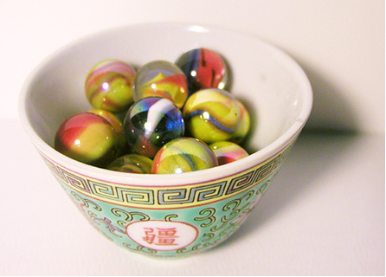
This reference photo is 5" x 7". Let’s say you want to make a 5" x 7" painting from this photo. So drawing the grid will be pretty straightforward. But if you want to make a large painting, you could also make a painting that is 10" x 14" or 15" x 21" or 20" x 28". Why those sizes and not other sizes? Because those sizes are the same ratio as the 5" x 7" reference photo. In other words,
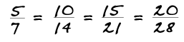
The size of your artwork must always be equally proportionate to the size of the reference photo.
Here is what you want your grid to look like:
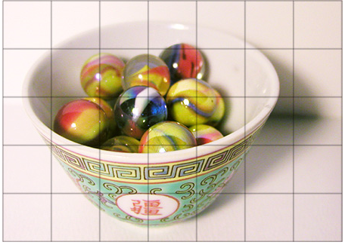

STEP 2: DRAWING THE GRID
-Each square is 1 cubic inch. To draw this grid, put your ruler at the top of the paper, and make a small mark at every inch.
-Place the ruler at the bottom of the paper and do the same thing.
-Then use the ruler to make a straight line connecting each dot at the bottom with its partner at the top.
-Now place the ruler on the left side of your paper, and make a small mark at every inch.
-Then place the ruler on the right side of the paper, and do the same thing.
-Then, using your ruler, make a straight line connecting the dots on the left with their partners on the right.
- Now repeat the same procedure on your paper:
You've now got a grid on your work surface that perfectly matches the grid of your reference photo.
Because this will be the exact size as the reference photo, the squares on this canvas are also 1 cubic inch. If this painting was going to be 10" x 14", then the squares would need to be 2 cubic inches, because
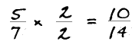
Basically, to enlarge the image, you'll need to do this kind of math .If you're not sure whether you've done the math correctly, just count the number of squares in each row and in each column, and ask yourself:
- Are there an equal number of rows and columns on the canvas as there are on the reference photo?
- Are the squares on the canvas perfect squares, just like the squares on the reference photo?
If you can answer yes to both of those questions, you've got the gridding process down pat!

STEP 3: TRANSFERRING THE IMAGE
I find that it's sometimes easier to keep track of where I am amongst all those little squares by marking them numerically and alphabetically along the edges of the paper and canvas. This way if I get lost, especially within a much larger painting with many more squares, I can easily locate where I want to be. I write the numbers and letters really small and lightly, so that they can be easily erased. It looks something like this:
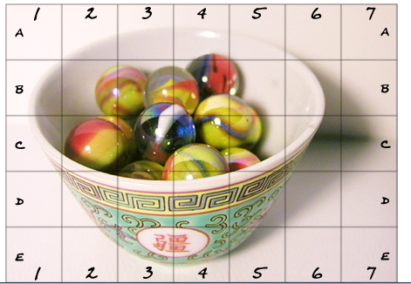
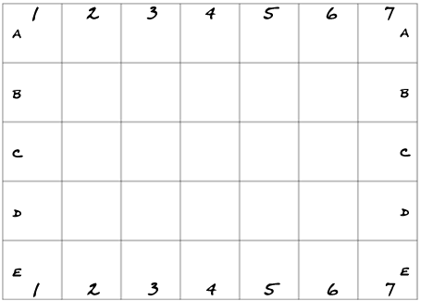
So now your task is to transfer what you see in the reference photo, block by block, onto your canvas or paper. When I use the grid method, I always start at the top left corner, and work my way across and down. Since Square A1 is blank in the reference photo, we'll move on to A2. Draw in A2 exactly as you see it:
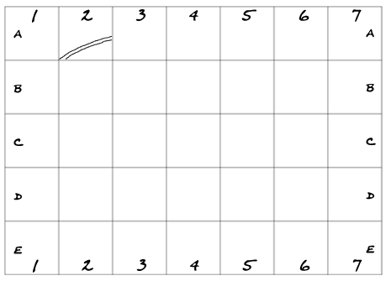
The grid basically divides the original image into smaller blocks so that you can more easily see what belongs where. You can see that in the photo, the left side of the little bowl intersects the corner at the bottom left of Square A2. So you draw the line from there to just below the middle of the line between A2 and A3.
That first block was easy! Now do the next block:
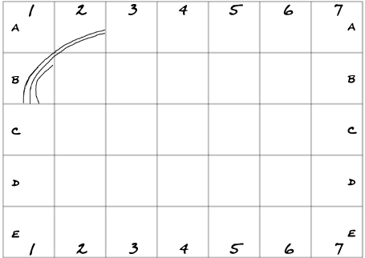
So you see that as you are transferring the image, you are only paying attention to one block at a time. Don't worry about the other blocks - just focus on that one block. Try as much as you can to copy exactly what you see in that little square in the photo to the corresponding square on your paper or canvas. Focus on getting the placement of each line just right! Here we go:
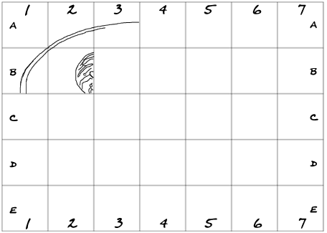
And then the next square: 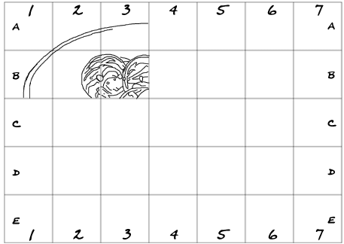
I think you get the idea now. Basically you continue on in this manner, until all the squares are done and the image is completely transferred.

